Remarkable performance in full capacity

[Watch Video](https://www.kingston.com/en/video/play?videoId=-Idulver_7qCB1QAxQu3tVaZUX5fPFN0NLaZEwHK-wKuNP59f1ltEtA4cLrb-efYn2pC5i262xuqNELM05gQjw2&start=0&autoPlay=False&chromeless=False&captionOption=No)

KC600

* [Intro](https://www.kingston.com/en/ssd/kc600-sata-solid-state-drive#product-features)
* [Key Features](https://www.kingston.com/en/ssd/kc600-sata-solid-state-drive#key-feature)
* [Specifications](https://www.kingston.com/en/ssd/kc600-sata-solid-state-drive#specifications)
* [Resources](https://www.kingston.com/en/ssd/kc600-sata-solid-state-drive#links)
* [Datasheet](https://www.kingston.com/datasheets/kc600_us.pdf)

[**Buy**](https://www.kingston.com/en/ssd/kc600-sata-solid-state-drive#atc)

KC600 2.5" and mSATA SSDHardware-based self-encrypting drive with 3D TLC NAND

Kingston’s KC600 is a full capacity SSD designed to provide remarkable performance and optimized to provide functional system responsiveness with incredible boot, loading, and transfer times. It comes in both 2.5" and mSATA form factors using SATA Rev 3.0 interface with backwards compatibility. The KC600 utilizes the latest 3D TLC NAND technology while supporting a full-security suite that includes AES 256-bit hardware encryption, TCG Opal 2.0, and eDrive. It features read/write speeds up to 550/520MB/s1 to efficiently store your data up to 2TB2.

* Remarkable performance
* Features the latest 3D TLC NAND technology
* Supports a full-security suite (TCG Opal 2.0, AES 256-bit, eDrive)
* Available in range of full capacities



**Ask an SSD Expert**

Planning the right solution requires an understanding of your project's security goals. Let Kingston's experts guide you.

[**Ask an Expert**](https://www.kingston.com/en/ssd/desktop-laptop-workstations/ask-an-expert)

Key Features

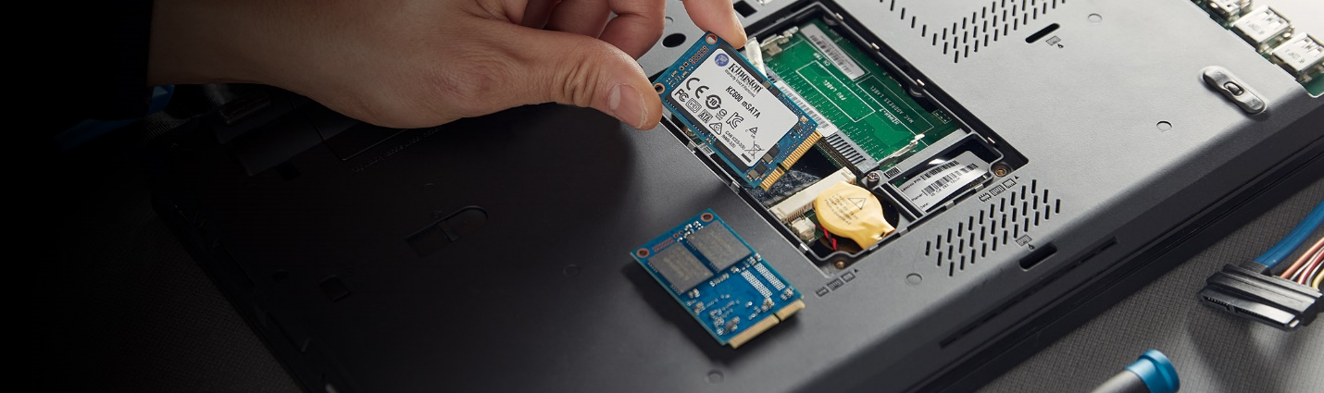

Remarkable Performance

Using the latest 3D TLC NAND technology, it enables read/write speeds up to 550/520MB/s1.



Full-security suite

Protect and secure your data with Kingston’s self-encrypting drive.



Multiple capacities

KC600 is available in a range of full capacities from 256GB to 2TB1

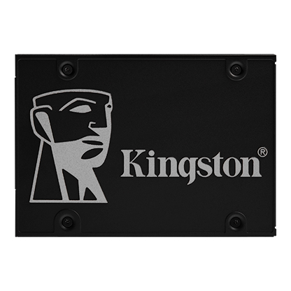

* [SKC600/256G SSD](javascript:void(0))
* [SKC600/256G SSD](javascript:void(0))
* [SKC600/256G SSD](javascript:void(0))

Capacity

 256GB

 512GB

 1024GB

 2048GB

Form Factor

 2.5"

 mSATA

* Part Number: SKC600/256G
* Includes [Acronis cloning software](https://www.kingston.com/cloning)
* SATA Rev 3.0
* XTS-AES 256-bit Encryption, TCG Opal 2.0, eDrive
* 3D TLC NAND technology
* Up to 550MB/s Read, 500MB/s Write

[**Where to Buy**](https://www.kingston.com/en/wheretobuy)

Specifications

* **2.5"**
* **mSATA**

|  |  |
| --- | --- |
| Form Factor | 2.5" |
| Interface | SATA Rev. 3.0 (6Gb/s) – with backwards capability to SATA Rev 2.0 (3Gb/s) |
| Capacities2 | 256GB, 512GB, 1024GB, 2048GB |
| Controller | SM2259 |
| NAND | 3D TLC |
| DRAM Cache | Yes |
| Encrypted | XTS-AES 256-bit encryption |
| Sequential Read/Write1 | 256GB — up to 550/500MB/s 512GB–2048GB — up to 550/520MB/s |
| Maximum 4K Read/Write1 | up to 90,000/80,000 IOPS |
| Power Consumption | 0.06W Idle / 0.2W Avg / 1.3W (MAX) Read / 3.2W (MAX) Write |
| Dimensions | 100.1mm x 69.85mm x 7mm |
| Weight | 40g |
| Operating temperature | 0°C~70°C |
| Storage temperature | -40°C~85°C |
| Vibration operating | 2.17G Peak (7-800Hz) |
| Vibration non-operating | 20G Peak (10-2000Hz) |
| Life expectancy | 2 millions hours MTBF |
| Warranty/support3 | Limited 5-year warranty with free technical support |
| Total Bytes Written (TBW)4 | 256GB — 150TB 512GB — 300TB 1024GB — 600TB 2048GB — 1200TB |